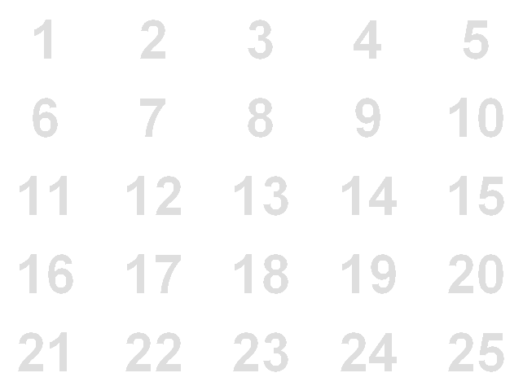
The third term of an arithmetic series is 9 and the 7th term is 33. Find the first and second terms. | The gradient of the curve $y=f(x)$ at any point is $\frac{4}{x^{2}}$. Find the equation of the curve if it passes through the point $(\frac{1}{2}, -1)$. | Find the set of values of $x$ which satisfy  $$x^{2}-2x>3$$ | The lines 2y = 3x - 2 and 3y + 2x = 1 intersect at the point P. Find the coordinates of P. | Simplify  $$\sqrt{18}+\sqrt{98}$$
A straight line passes through the points $(1, 4)$ and $(-3, 2)$. Find the equation of then line, give your answer in the form $ax+by+c=0$ | Sketch the graph of $y=2f(x)$  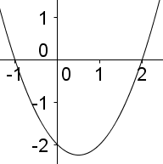 | For the curve with equation $y={3x}^{2}-8x$ find the equation of the tangent at the point $(2, -4)$ | Sketch the curve given by the equation  $$y=x^{3}+2x^{2}-3x$$ | Use the recurrence formula $u_{n+1}={2u}_{n}-1$ to find $u_{2}$, $u_{3}$ and $u_{4}$, given that $u_{1}=2$
For the curve with equation $y={3x}^{2}-8x$ find the equation of the normal at the point $(2, -4)$ | Find $x$ and $y$  $$y=x-3$$  $$x^{2}-3y^{2}=9$$ | Find the distance between the points (4,3) and (-6,-7) giving your answer as a simplified surd, | Evaluate  $$\sum_{1}^{10}{(3r+2)}$$ | Given that  $${4x}^{2}+12x+c=0$$  has equal roots, find the value of $c$
Sketch the graph of  $$y=\frac{1}{x-2}$$ | ${mx}^{2}+3x+n=0$ has equal roots and the sum of the two constants $m$ and $n$ is given by $m+n=\frac{15}{4}$. Determine the values of $m$ and $n$. | Find the sum of the series  2, 6, 10, 14, …, 158 | Determine whether the lines $y-3x+3=0$ and $3y+x=6$ are parallel, perpendicular or neither | The equation  $$x^{2}+4x+k=0$$  Has no real roots. Find the set of possible values for $k$.
Given that  $x^{2}-4x-9$ can be written as ${(x+a)}^{2}+b$, where $a$ and $b$ are constants, find the values of $a$ and $b$ | Rationalise  $$\frac{\sqrt{3}}{3+\sqrt{2}}$$ | Solve  $$3^{x}=9^{x-1}$$ | If $f^{'}\left(x\right)={3x}^{2}-2x+1$, find the equation of the curve $f(x)$, given that $(1, 2)$ lies on the curve. | The midpoint of the points A and B is (2, -4) where A is (p, -2) and B is (3, q), find p and q

a= -3, d=6, 2nd term is 3 | $$y=\frac{-4}{x}+7$$ | $$x<-1 and x>3$$ | $$\left(\frac{8}{13},\frac{-1}{13}\right)$$ | $$10\sqrt{2}$$
$$x-2y+7=0$$ | 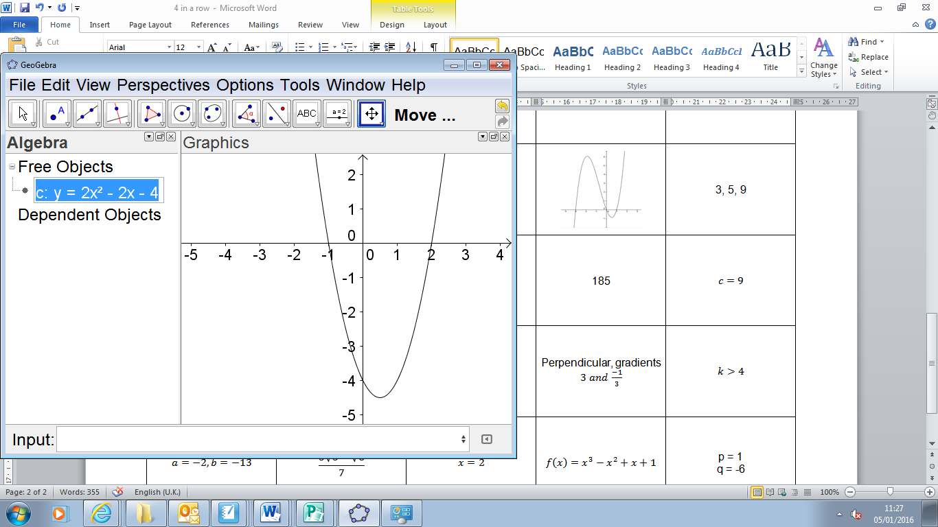 | $$y=4x-12$$ | 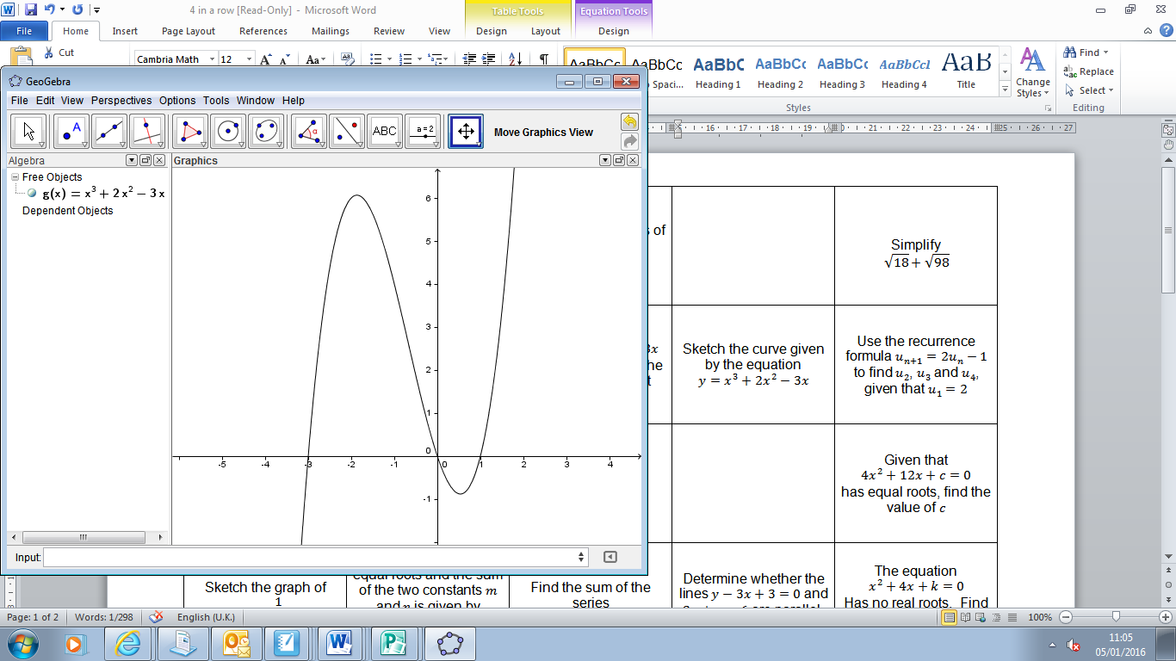 | 3, 5, 9
$$4y=-x-14$$ | $$x=3, y=0$$  $$x=6, y=3$$ | $$10\sqrt{2}$$ | 185 | $$c=9$$
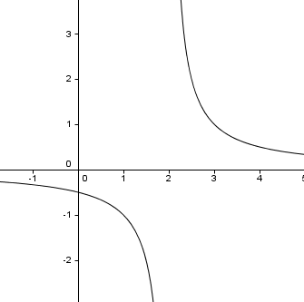 | $n=\frac{3}{4}, m=3$ or  $$n=3, m=\frac{3}{4}$$ | n=40, S = 3200 | Perpendicular, gradients $3 and \frac{-1}{3}$ | $$k>4$$
$$a=-2, b=-13$$ | $$\frac{3\sqrt{3}-\sqrt{6}}{7}$$ | $$x=2$$ | $$f\left(x\right)=x^{3}-x^{2}+x+1$$ | p = 1  q = -6

1 | 2 | 3 | 4 | 5
6 | 7 | 8 | 9 | 10
11 | 12 | 13 | 14 | 15
16 | 17 | 18 | 19 | 20
21 | 22 | 23 | 24 | 25

