The angle in a  semi-circle is  …….. radians |  |  |  |  |  |  |  |  |  |  | The angle between  a radius and a tangent is  …….. radians
Opposite angles in a quadrilateral add up  to …….. radians |  |  |  |  |  |  |  |  |  |  | Two tangents which meet at a point outside a circle are  ………………………..
The angle at the centre of the circle  is ……………….. the angle on the circumference |  |  |  |  |  |  |  |  |  |  | A triangle which has one vertex at the centre of a circle and two vertices on the circumference is …………………………….
Angles in the same segment standing on the same chord are  ………………………. |  |  |  |  |  |  |  |  |  |  | The perpendicular from a chord to the centre of a circle ………………….. the chord
 | 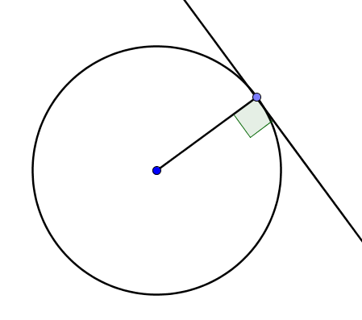 |  |  | Glue here | $$\frac{π}{6}$$  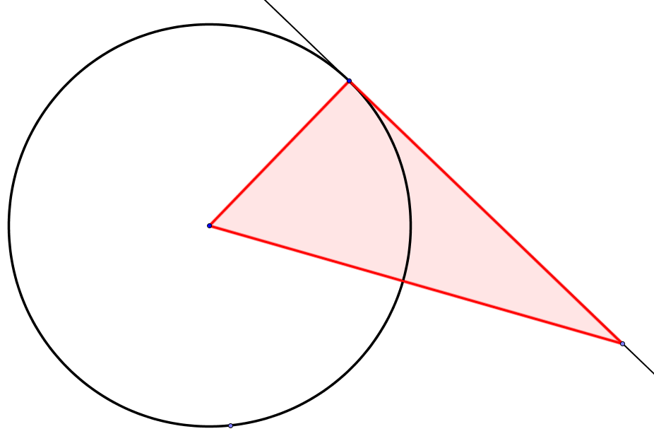  $$α$$  $$θ$$ | 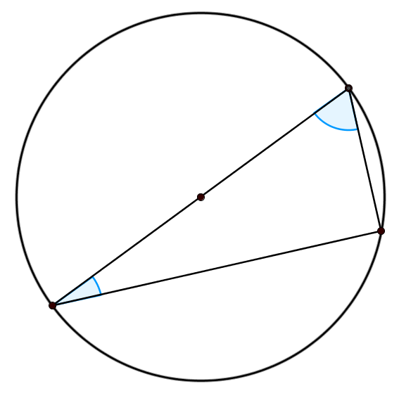  $$\frac{2π}{5}$$  $$α$$  $$θ$$ |  | Glue here |  |  | 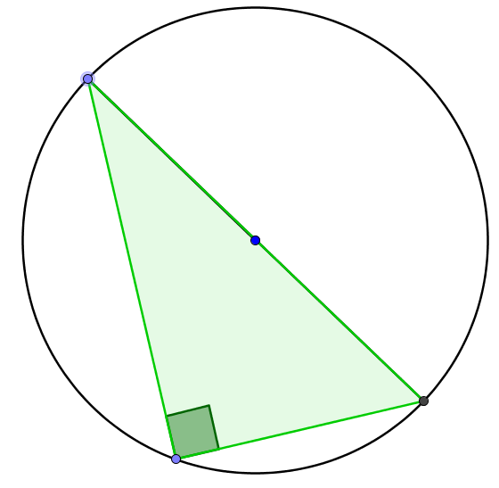
 | 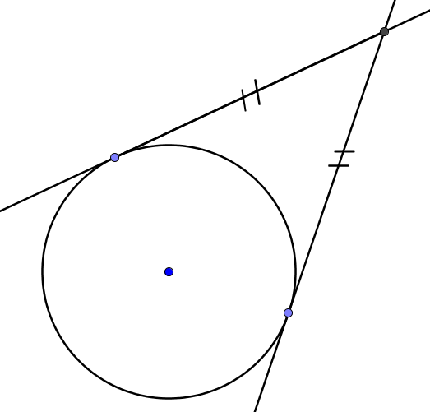 |  |  | Glue here | 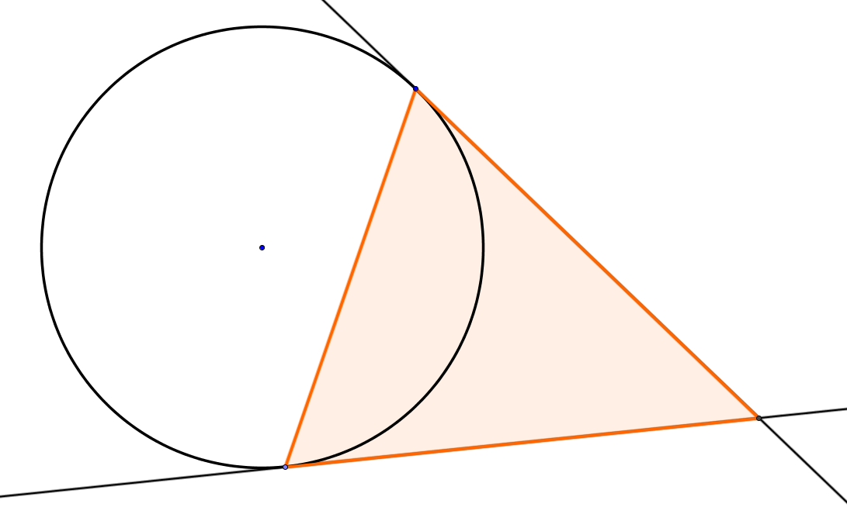  $$\frac{π}{3}$$  $$α$$  $$θ$$ | 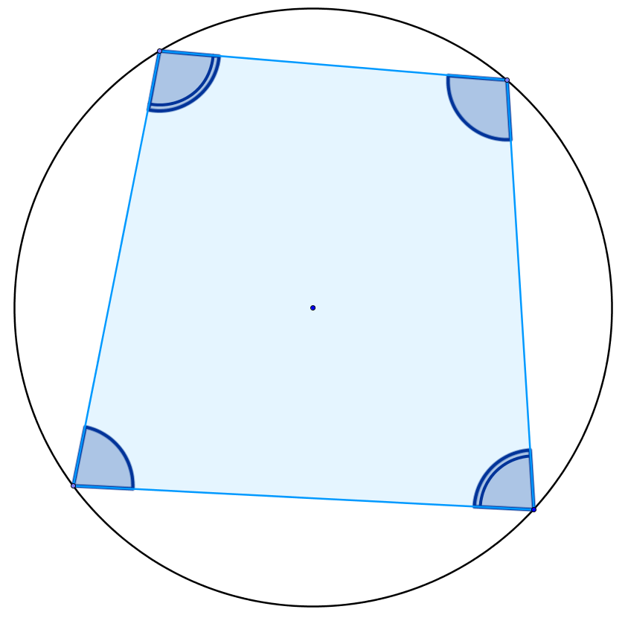  $$θ$$  $$α$$  $$\frac{π}{8}$$  $$\frac{π}{3}$$
 | 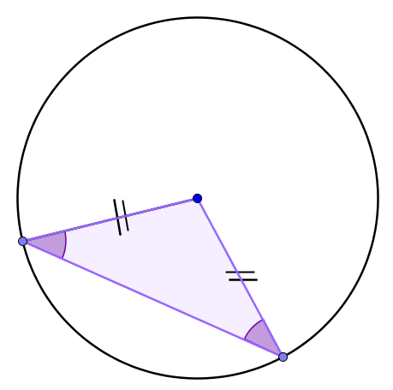 |  |  | Glue here | 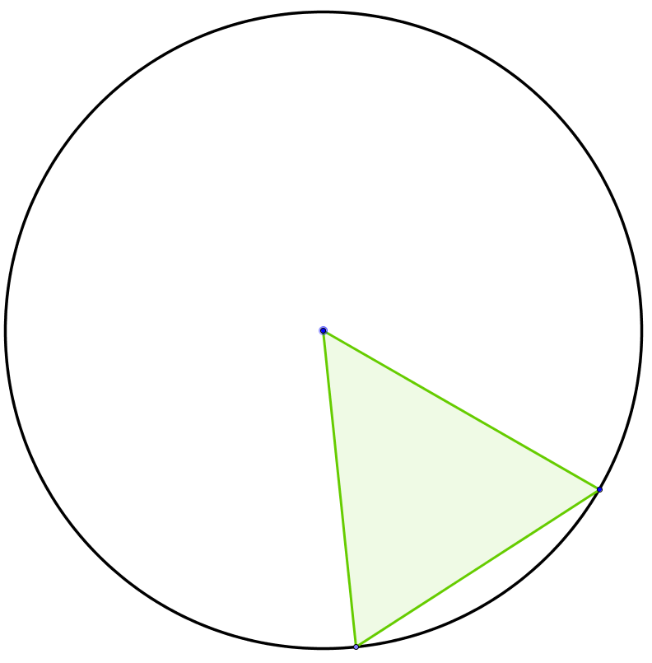  $$\frac{π}{8}$$  $$θ$$ | 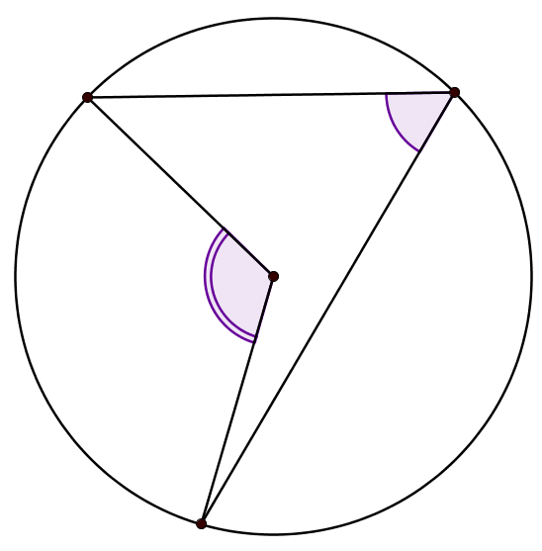  $$\frac{π}{4}$$  $$θ$$
 | 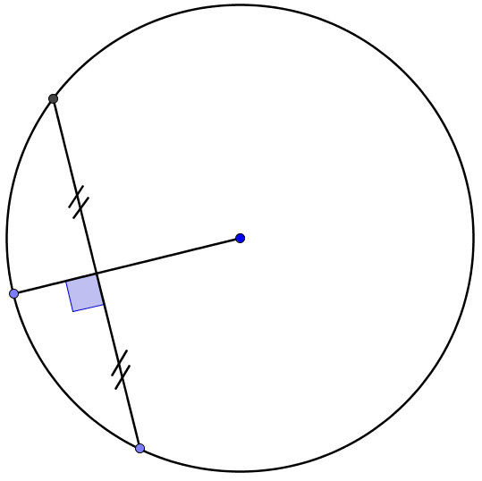 |  |  | Glue here | 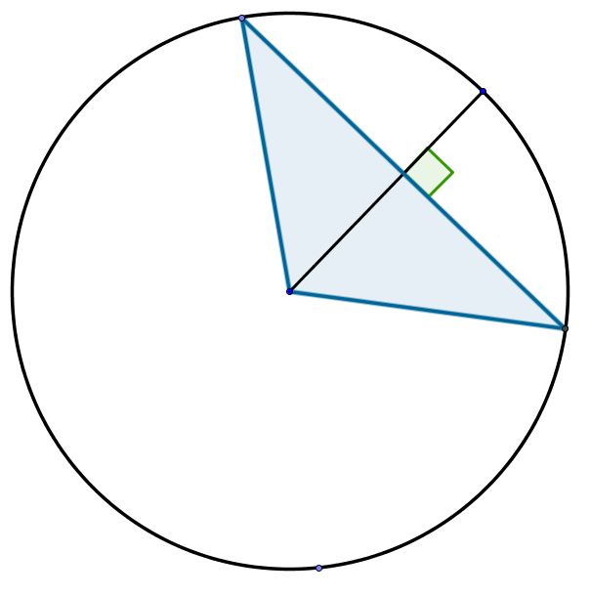  $$\frac{π}{8}$$  $$α$$  $$θ$$ | 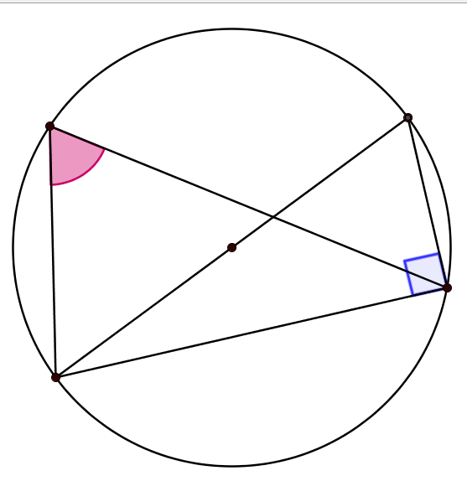  $$\frac{π}{6}$$  $$θ$$ |  |  |  |  | 