Describing transformations

Fully describe each of the following transformations, when you finish move on to P 66 Ex 17F.
Key points  To fully describe a transformation you need to state what type of transformation it is and then the points below.  Translations  You need to give a vector to describe the translation.  $$\left(\begin{matrix}left/right \\ up/down\end{matrix}\right)$$  Rotations  You need to give three things:  - The centre of rotation  - The angle of rotation  - The direction of rotation  Reflections  You need to give the equation of the line.  Enlargements  You need to give two things:  - The centre of enlargement  - The scale factor  The origin is the point (0,0)
  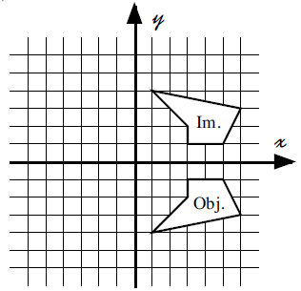 | 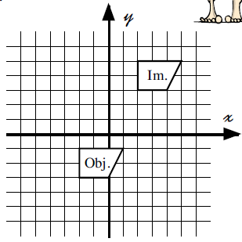
  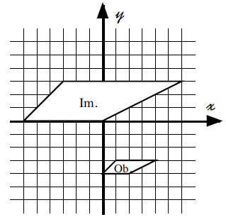 | 