C1 - Quadratic Inequalities

Instructions | 1. $x^{2}+x-12>0$ | 2. $x^{2}-x-12<0$ | 3. $12-x-x^{2}>0$
Factorise to find the roots
Sketch to find the section or sections needed
State the range of solutions
4. $12-4x-x^{2}<0$ | 5. $x^{2}+3x-10>0$ | 6. $8+2x-x^{2}<0$ | 7. $2x^{2}-6x-8>0$

Put the steps in order to solve the first 4 inequalities. | Amber | Put the steps in order to solve the first 4 inequalities. | Red
$$(x+4)(x-3)$$  $$x=-4, x=3$$ | $$(x-4)(x+3)$$  $$x=4, x=-3$$ | $$(x+4)(x-3)$$  $$x=-4, x=3$$ | $$(x-4)(x+3)$$  $$x=4, x=-3$$
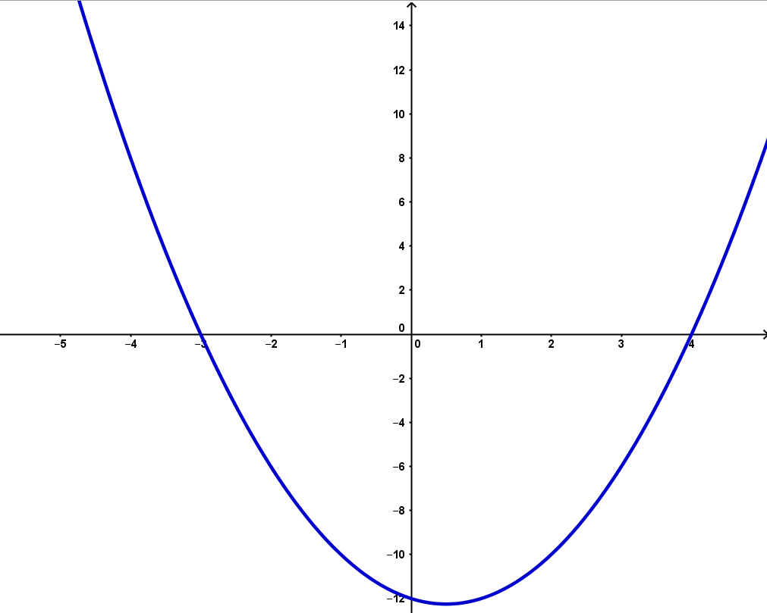 | 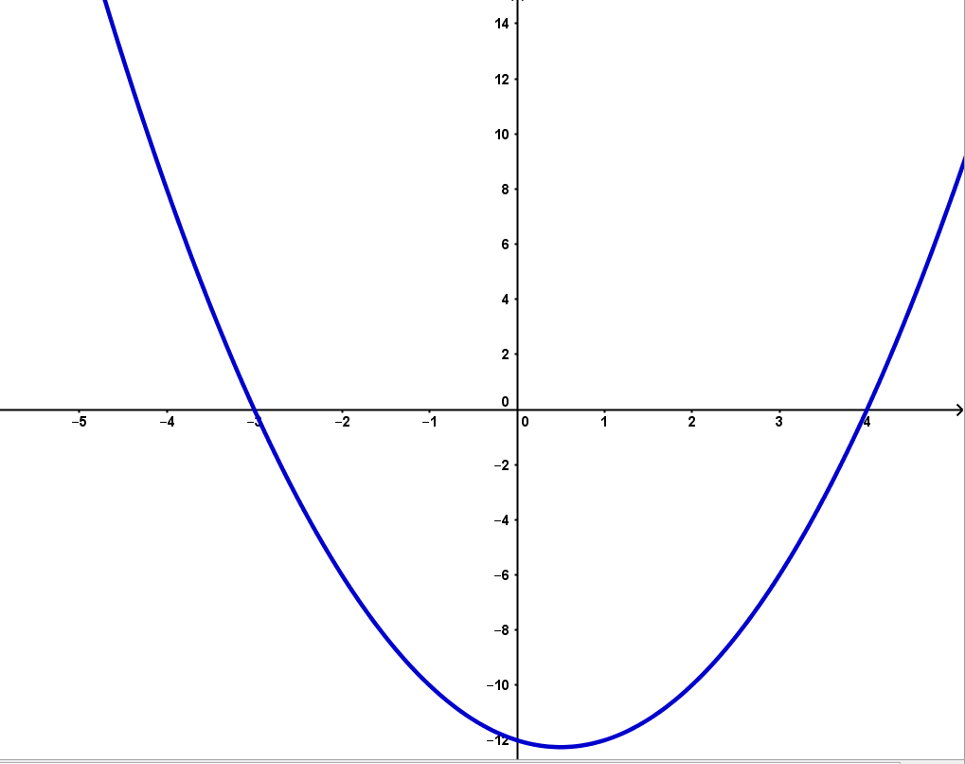 | $$x<-4, x>3$$ | $$-3<x<4$$
$$x<-4, x>3$$ | $$-3<x<4$$
$$(x+4)(3-x)$$  $$x=-4, x=3$$ | $$(x+6)(2-x)$$  $$x=-6, x=2$$ | $$(x+4)(3-x)$$  $$x=-4, x=3$$ | $$(x+6)(2-x)$$  $$x=-6, x=2$$
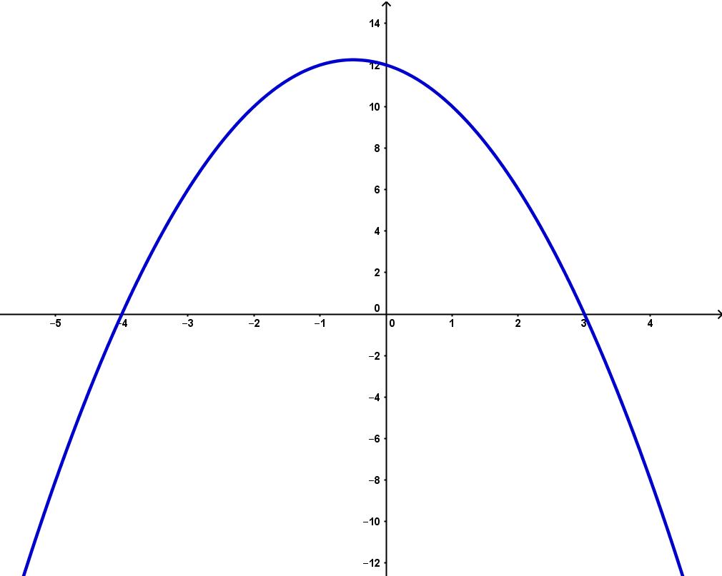 | 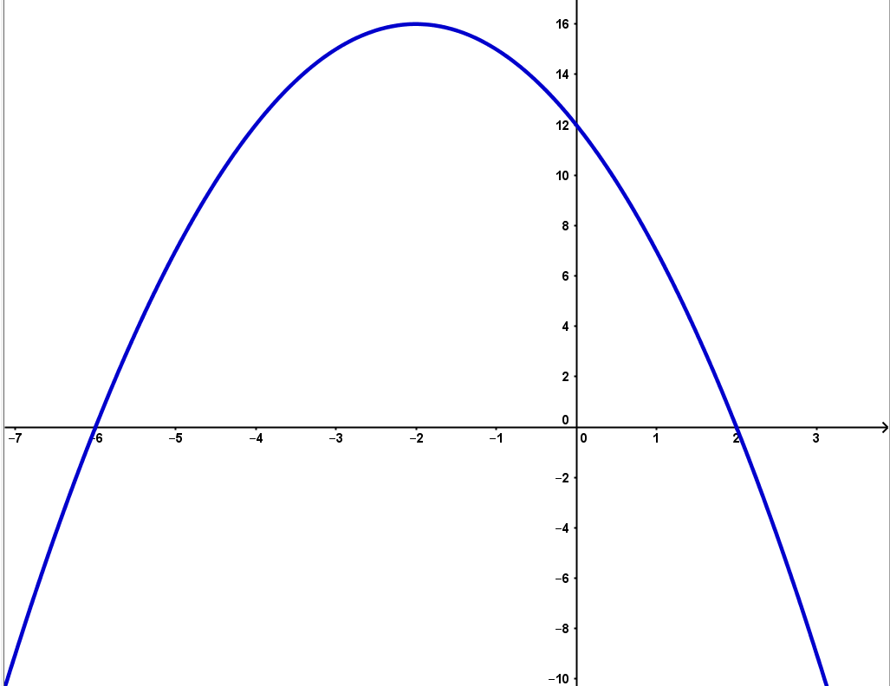 | $$-4< x<3$$ | $$x<-6, x>2$$
$$-4< x<3$$ | $$x<-6, x>2$$

