 | Constant acceleration equations for Mechanics 1 | An equation with  u, v, a & t |  | Constant acceleration equations for Mechanics 1 | An equation with  u, v, a & t | An equation with  u, v, a & t | A formula without  s
 | Constant acceleration equations for Mechanics 1 | An equation with  s, u, v, & t |  | Constant acceleration equations for Mechanics 1 | An equation with  s, u, v, & t | An equation with  s, u, v, & t | A formula without  u
 | Constant acceleration equations for Mechanics 1 | An equation with  s, u, a & t |  | Constant acceleration equations for Mechanics 1 | An equation with  s, u, a & t | An equation with  s, u, a & t | A formula without  v
 | Constant acceleration equations for Mechanics 1 | An equation with  s, u, v & a |  | Constant acceleration equations for Mechanics 1 | An equation with  s, u, v & a | An equation with  s, u, v & a | A formula without  a
 | Constant acceleration equations for Mechanics 1 | An equation with  s, v, a & t |  | Constant acceleration equations for Mechanics 1 | An equation with  s, v, a & t | An equation with  s, v, a & t | A formula without  t

 | Constant acceleration equations for Mechanics 1 | A formula without  s |  | Constant acceleration equations for Mechanics 1 | A formula without  s
 | Constant acceleration equations for Mechanics 1 | A formula without  u |  | Constant acceleration equations for Mechanics 1 | A formula without  u
 | Constant acceleration equations for Mechanics 1 | A formula without  v |  | Constant acceleration equations for Mechanics 1 | A formula without  v
 | Constant acceleration equations for Mechanics 1 | A formula without  a |  | Constant acceleration equations for Mechanics 1 | A formula without  a
 | Constant acceleration equations for Mechanics 1 | A formula without  t |  | Constant acceleration equations for Mechanics 1 | A formula without  t
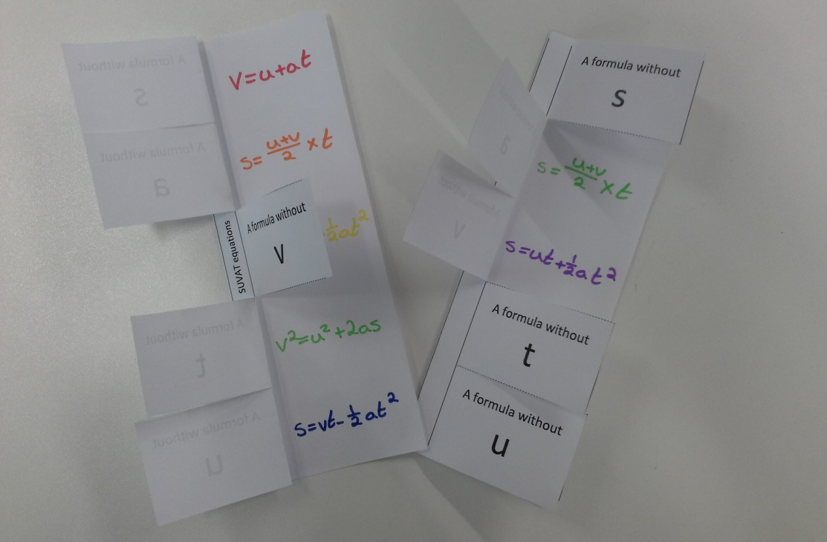
The finished thing should look something like this.

If like me you adapt things and use this to make something else I’d love to see what you’ve done. My email address is j.c.hughes@hotmail.co.uk
Thanks Jenny aka Maid of Steel

I made 2 slightly different versions so left both on for you to choose from.
When you print it will complain about things being outside of the margins but that is to make best use of paper and keep the cutting out to a minimum don’t worry it will be fine on most printers.
There are 2 per sheet so either give one between two or cut in half first.
Have students fold in half vertically and then cut along the dotted lines.
Stick onto a sheet or into a book and then fold back each door to write in the correct formulas.

