Angles in Parallel lines – Facts you need to know | Angles on a straight line add up to …….. | Glue here | 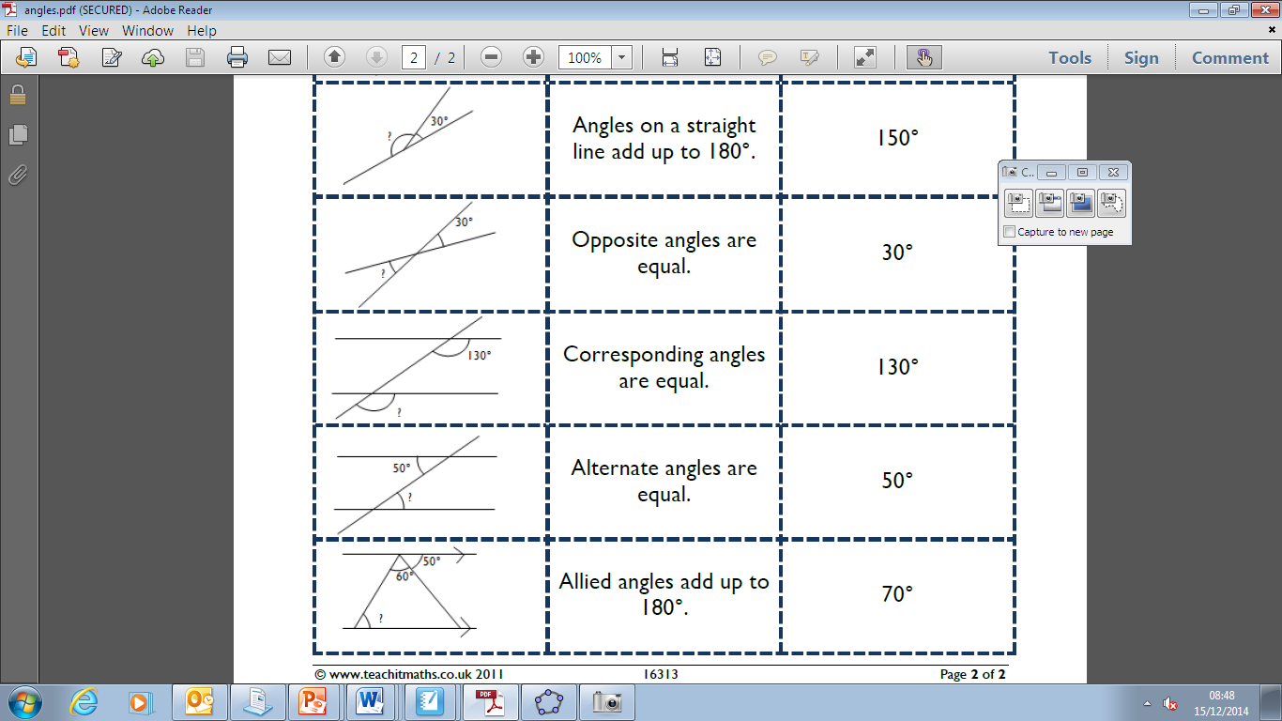 | Example
Angles in Parallel lines – Facts you need to know | Angles at a point add up to …….. | Glue here | 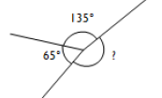 | Example
Angles in Parallel lines – Facts you need to know | ………..…… angles are …………… | Glue here |  | Example
Angles in Parallel lines – Facts you need to know | ………..…… angles are …………… | Glue here | 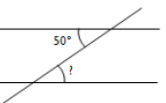 | Example
Angles in Parallel lines – Facts you need to know | ………..…… angles are …………… | Glue here |  | Example
Angles in Parallel lines – Facts you need to know | ………..…… angles add up to …… | Glue here |  | Example

Word Bank: Alternate, Corresponding, Opposite, Allied

