Section 1: Picture round
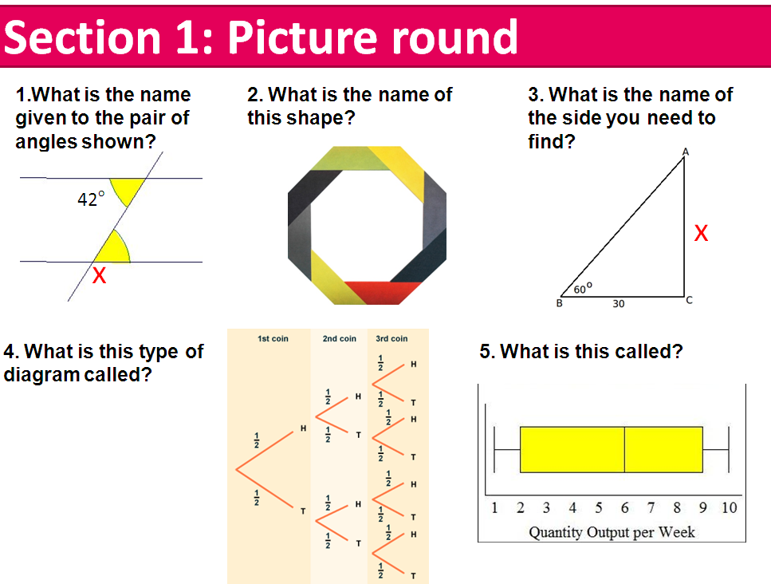
42

Section 1: Picture round
42

Team name Team name

Section 1: Picture round Section 1: Picture round
1  2  3  4  5 |  | 1  2  3  4  5

Section 2: Multiple choice Section 2: Multiple choice
1  2  3  4  5 |  | 1  2  3  4  5

Section 3: Formulas Section 3: Formulas
1  2  3  4  5 |  | 1  2  3  4  5

Section 4: Quick calculations Section 4: Quick calculations
1  2  3  4  5 |  | 1  2  3  4  5

