10 - Indices | Simplify  $$\frac{a^{3}×a^{6}}{a^{2}}$$ | 9 – solving equations | Solve the equation  $$2(x-2) = 10$$
8 - Product of prime factors | Write 84 in the form $2^{a}×3^{b}×7^{c}$ | 7 – HCF/ LCM | Find the highest common factor of 84 and 36.
6 - Probability | 40 seeds are planted find an estimate for the number that don’t grow | 5 - Inequalities | Find largest integer that $x$could be for the following inequality  $$3x + 8 < 29$$
   | Grows | Doesn’t grow
  Probability | 0.75
4 - Cumulative frequency | Find the interquartile range  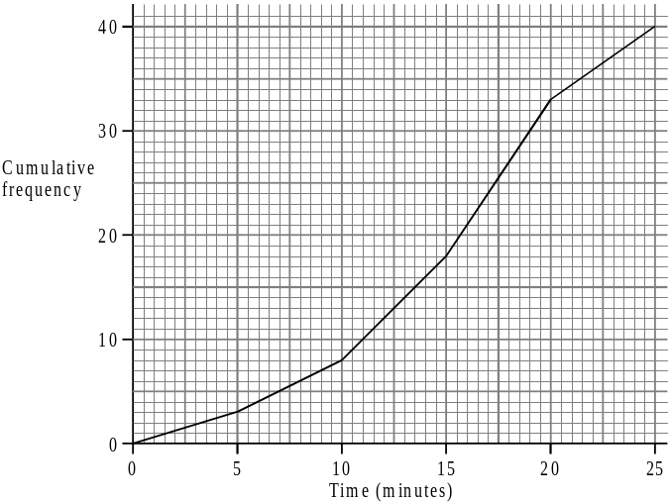 | 3 - Transformations | Fully describe the transformation shown  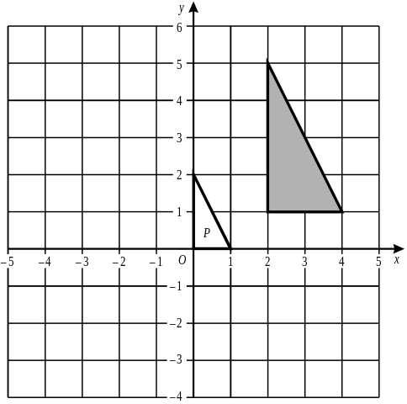
2 - Angles | 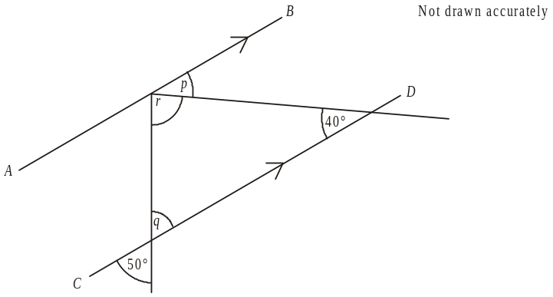  Find each of  the angles, give  reasons for  your answers | 1 - Proportion | James wants to make a cake for 9 people. He has 10 eggs, 200g butter 300g of flour and 400g sugar. Does he have enough?  Sponge cake  180g flour  180g sugar  160g butter  4 eggs  Serves 6 people
11-Expand & simplify | Expand and simplify  $$3(x+2)-2(x-4)$$ | 12-Factorise | Factorise fully  $${9x}^{2}y+3x$$
13 – Share in a given ratio | On Friday the ratio of the time Priya is sleeping to the time she is awake is 3 : 5.  She is sleeping for less time than she is awake.  Work out the number of hours that she is sleeping on Friday. | 14 - Fractions | $$\frac{1}{4}+\frac{2}{3}=$$  $$\frac{3}{7}×\frac{4}{5}=$$
15 – Plot a line graph | On the grid below, draw the graph of y = 2x – 3 for values of x from –2 to +3.  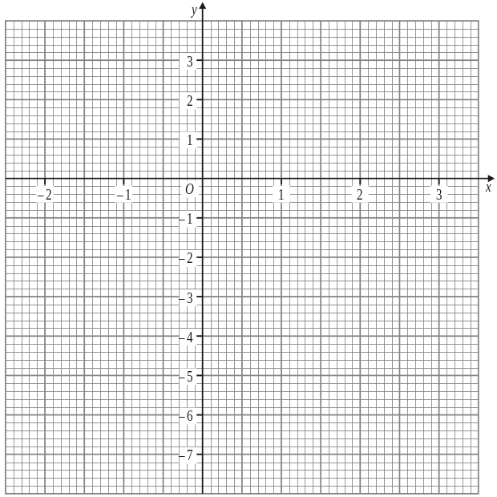 | 16 – Scatter graphs | Describe the relationship between the number of ice cream sales and the midday temperature.  Estimate the temperature on a day when 120 ice creams were sold.  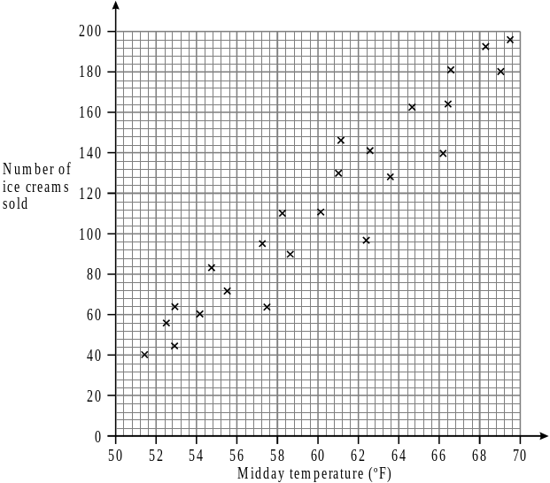
17- Reflections | Reflect the shaded triangle in the line x = 2  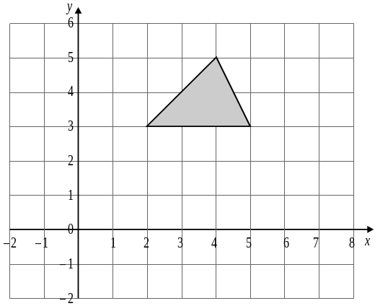 | 18 - Rotations | Rotate the shaded triangle 90º clockwise about the point (-1,1)  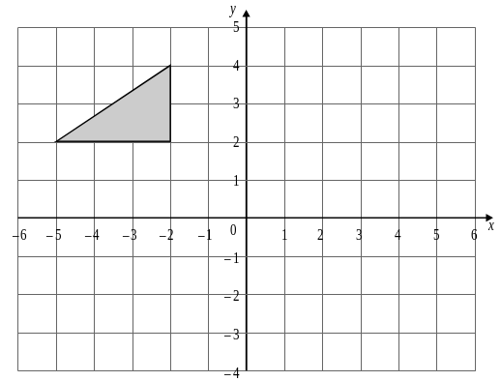
19 – Translations | Translate the shaded triangle by the vector $\left(\begin{matrix}5 \\ -4\end{matrix}\right)$ | 20 - Volume | Work out the volume of the prism  